International Development Studies Network at the Research Centre for the Social Sciences (ReCSS), University of York  Development, Participation and the ever-present Tyrannies?  Uma Kothari (Manchester) and Bill Cooke (Lancaster)  A workshop to be held on Monday 21 July from 12.30pm – 4.00pm.  Venue: ReCSS Training Room (YH/001b)  Participation: The New Tyranny (Cooke and Kothari, 2001) was a widely cited and influential landmark in development studies, and had a profound impact on development practice. The book sought to show how the then prevalent model of participatory development led to the unjust and illegitimate exercise of power by multi-lateral and bi-lateral development agencies, and to reveal the relationship between the rhetoric of empowerment and realities of power and appropriation. In this workshop, to mark the inception of the International Development Network at the University of York, the book’s editors (Bill Cooke and Uma Kothari) will outline the emergence and history of Participation: The New Tyranny. They will each reflect on how their research and ideas developed after the publication of the book, and will then present what they see as the key current challenges in international development and identify new areas for research to address these. |  | 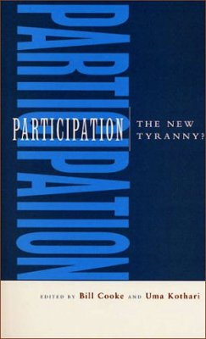
Uma Kothari is Professor of Migration and Postcolonial Studies in the School of Environment, Education and Development, Head of the Institute for Development Policy and Management and Associate Director of the Brooks World Poverty Institute at the University of Manchester. | Bill Cooke is Professor of Management and Society, and formerly Head of the Department of Organization, Work and Technology at Lancaster University Management School, and is joining The York Management School in September as Professor of Strategic Management
Organized by Simon Mollan, The York Management School: Simon.Mollan@york.ac.uk
To register please use the following link: http://doodle.com/tgsrnn4tsqurbiwa

